PCT Punch Clock Timer
Version 0.101
06/21/15

Table of Contents
Overview 1
Control Buttons Used in the Application 2
Features 2
Menus 3
Tasks 3
Reports 3
Help 4
About 4
Operation 4
Active Task Button 4
Task Button Right-Click 4
Add a New Task 5
Edit Tasks 6
Add Hidden Tasks for the Day 6
Misc Task 7
Order Tasks 7
Report Week's Time 8
Reports on Notes 8
History 8
Configuration 9
Logs and Backups 10
Further Reporting 10
PCT_DB 11
PCT_Notes_DB 11
Installation 12

Overview
PCT Punch Clock Timer is designed as a desktop tool to capture time spent on various project tasks. It works in harmony with the HP PPM (Project Portfolio Manager) time sheets. PCT may be thought of as a many-button time clock.
Projects and tasks are defined in the tool, and time spent on them is recorded for each day. Miscellaneous tasks are predefined in the database.
Weekly reports of time spent are available, and may be used to fill in a PPM time sheet.
Project notes may be taken in the tool also, with available reports written to text files.
PCT uses a SQLite3 database to record time. The program is written in Python 3.

Control Buttons Used in the Application
 | Exit the dialog or application |  | Subtract the time
 | Process the changes |  | Add the time
 | Stop all time gathering |  | Delete
 | Silence task alarm (background: yellow is silent; blue is on) |  | Move up in the list
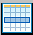 | Select from a list |  | Move down in the list
 | Display a list |  | Pop up a calendar dialog to select a date

Features
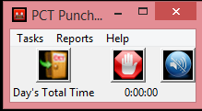
You may define an unlimited number of Projects and Tasks on which you are spending time. Each task will be represented as a user-defined button. One button is active and recording time at any given moment. If there is a task accumulating time, clicking a different task button will change the time accumulation to it, and clicking the Stop button will halt all time accumulation. A single task may also be set to begin recording time at program start. Tasks may have an alert pop-up as a reminder that the task is recording time. The Silence button may be used to quiet the button alert feature (button turn a yellow background) if the button has an alert feature set (button has a blue background) to remind you that it has been pressed and are you still recording time for the selected task.
Most fields' menus and buttons have tool tips to help you determine what has to happen at each point.

Menus

Tasks
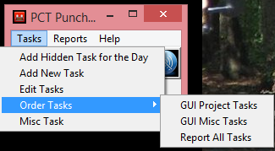
Tasks menu is where new projects and tasks are entered and managed. Tasks may be defined as hidden, during addition or editing, if they are not frequently used. Shown tasks always appear on the screen. Hidden tasks appear at the bottom of the task button list when they are added to the screen for the day. On subsequent days they again are hidden until made to show. Task options are edited on the Edit Tasks menu, discussed later in this guide. Task order is adjusted on Order Tasks menu for Project Tasks on the screen, Miscellaneous Tasks on the screen or all tasks in the reports. Reports may be ordered so they more closely follow the order in the PPM time sheet, the on-screen order may be arranged by frequency of use. Miscellaneous tasks may be added to a time record to remind you that such time was taken, so you may accurately reflect all of your time in the PCT tool and in PPM. The week's total time, seen in reports on the Reports Menu, should approach the same total value, providing a cross check that you properly transcribed your time from PCT to PPM.

Reports
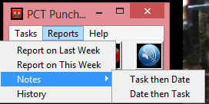
The Reports menu is where you see the time for current or previous week. You may also see the notes you have entered (how to enter notes is described later), ordered by task or by date. Notes reports are written to text files and placed in a folder controlled by a configuration option. The default is reports under the program folder. History allows for the viewing and editing of all tasks for any arbitrary date.

Help
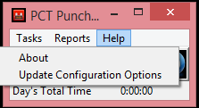
The Help menu displays the About dialog with the program version information. It also lets you manage configuration options.

About
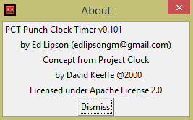

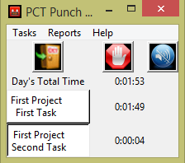
Operation

Active Task Button
Click a task button to activate the clock for that button. Click a different task button to switch. The Stop button will halt all time accumulation. Tasks which have an alert time will have a blue background, while a clear background indicates no reminder will be given that the task button has been clicked.

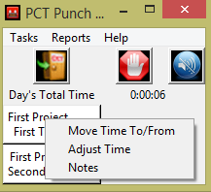
Task Button Right-Click
Each Task button has a menu of right click options. They are:
- Move time to the clicked task from another task. More time than recorded may be moved, setting the source/from task to zero time.

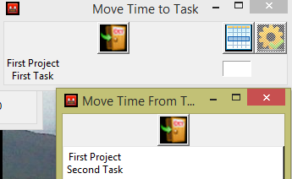
Use the List From Task button to display the possible source/from tasks. Click on a source/from task to select it. Enter the time in the field. Use the active Process button to move the entered time.

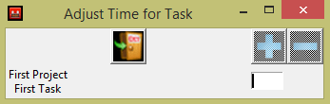
- Adjust the time up or down for a task, entering the number of minutes and using the Plus or Minus button to adjust the time accordingly. You may subtract more time than that recorded to set the time to zero.

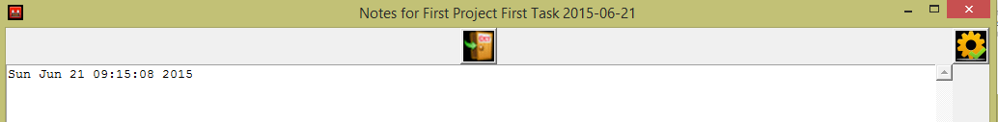
- Notes may be added for a task. A text entry box will open for you to record notes. If there are previous notes for the tasks from previous days, they will be displayed under the current day's notes so you may refer to them. The number of previous days notes and the text window sizes are configured in the configuration section of the application.

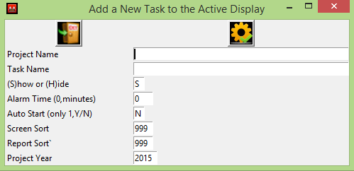
Add a New Task
Fill in the fields as indicated. Project name is optional. Task name is required. This is where you set the tasks initial display option, to be Shown on the initial start of the program or Hidden until needed. You may set the alarm time so you are reminded that the button is recording time, or use zero to not have an alarm. The Silence button may be used to stop the alarm for that time recording session. Auto Start is used to tell the program at start up whether to begin recording time or not. Only one is auto started, the one sorted to the top of the display screen. Sort order for the screen and reports are entered. The Project Year is used to separate tasks by calendar year.
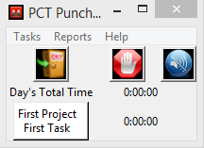
The Process gear button is used to cause the window to close and add the Project Task. The newly added Project Task appears on the screen, even if it has been marked as hidden. The hidden attribute is honored on subsequent starts of the program.

Edit Tasks
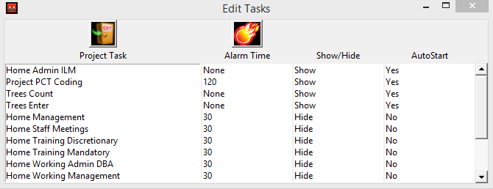
Edit Tasks opens a window which shows all tasks. Click on a task name to open a dialog where the task properties may be updated.
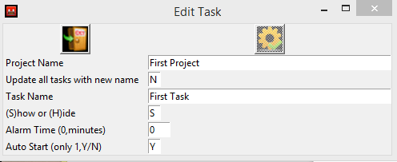
You may edit the project name and the task name. You may reset all of the tasks belonging to a given project to the new project name by changing the N to a Y for the Update all tasks with new name. The process button is not active until you make some change on the screen.

The Fireball Button will copy this years tasks to next year, so they all don't need to be entered manually. Pressing the button will also copy the miscellaneous tasks.

Add Hidden Tasks for the Day
This menu item will display a list of defined but not shown tasks, so you may bring them forward for use for a day. This option is useful when you have 50 tasks as it keeps the application normally smaller on the desktop, showing only those tasks in active use. Select the tasks to bring forward and press the Process button. The main task window will change from showing one task to two.

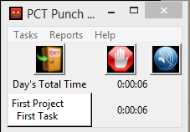
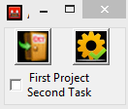
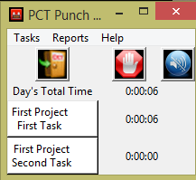

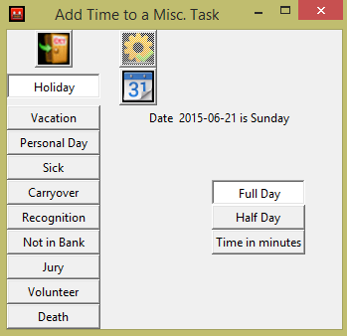
Misc Task
This menu button will open a dialog where you can select the type of miscellaneous task for recording. While they don't generate charges in the HP PPM system, the days are used to ensure your time sheet has the required number of hours for the week. It has been added to PCT so you remember that you had such a day and will see it in the weekly report of time, from which you transcribe you time to the PPM time sheet.
Select the type of day, a date, and whether it is a full, half or how many minutes. A full day is a configuration option and may be changed based on where your work and what you require. Press the active Process button (it is inactive to start) to cause the day to be recorded

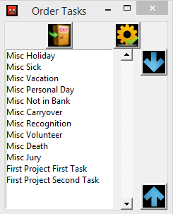
Order Tasks
The three order tasks sub-menu items all work the same. You select a task from the list and use the up and down arrows to move it to a new position in the list. The process button will cause all of the appropriate sort order information in the database to be adjusted to match the current order of the list.
GUI Task order effects the sequence of shown tasks, or the hidden tasks in the add hidden tasks for the day dialog. Hidden tasks are always shown at the end of the main screen when brought forward
GUI Misc is used to sequence the miscellaneous task buttons in the Miscellaneous day dialog.
The Report order dialog is used for the reports on the week's time. You should make it match the PPM time sheet order to facilitate the transcription of the time from PCT to PPM time sheets.

Report Week's Time
This report is the week Monday to Sunday time. It rounds up to 10ths of an hour (as lawyers do). It is either the previous week, from the day of the report, or the current week. It cross foots as the PPM time sheet does but owing to the rounding differences it will not cross foot exactly.
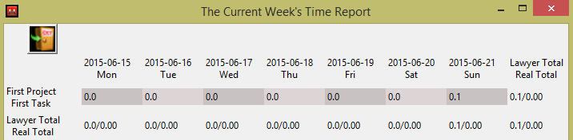

Reports on Notes
The Notes reports offer two options and use a configuration option. You may report on Notes by date then task or by task then date. The number of weeks back to include in the report is a configuration option. The text reports are written to files, generations of files to retain is a configuration option, in a location specified in the configuration. The default is a reports folder under the program folder.

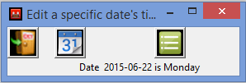
History
Any date's time records may be edited from the history dialog. Click on the calendar button to pop up a calendar so you may select a date. Use the List button to show the list of all possible tasks for that date.

The amount of time and whether the task was used on that date is shown to help in selecting which task to edit or create if it does not exist. Select the task you wish to edit by clicking on the Project Task name.

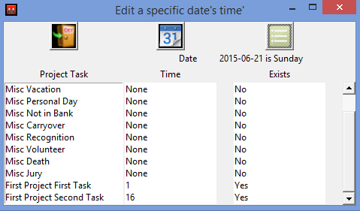

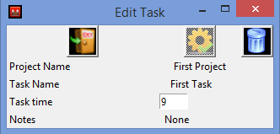
A new dialog will open for the selected task. If it is logical for the current task, the Delete button will be active to be used to delete the database record. Tasks with notes cannot be deleted. Notes, if they exist, will be shown, but they may not be edited. The time in minutes may be changed by pressing the Process button.

Configuration
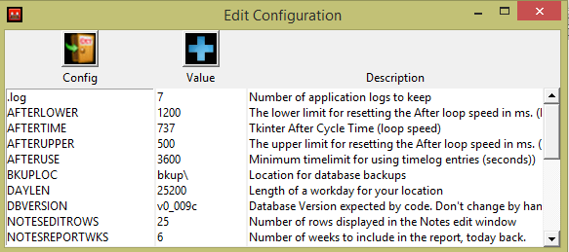
The configuration dialog opens the window with all of the configuration options. Click on the option key to edit it.

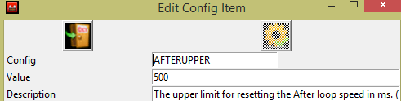
A new window will open.

You may also add options which are not currently defined but are used by the program. Any such option, which is missing but may be set if it exists, will be logged in the program log.
WARNING Could not find configuration item SHOWHIDROWLIM

Logs and Backups
There is a process log written each time the program starts. It is written into the program directory. A configuration option controls how many generations of the logs will be kept. One of the key items in the log is the time factor adjustment. Python tkinter loops only guarantee to wait as long as the repeat, but can wait longer. The program will attempt to adjust the loop speed at program exit so next time it will more accurately reflect the real time captured, where one second is a real clock second. On a busy system the repeat cycle may have to be set fast.
The time DB is backed up at each program start, into a location specified in the configuration. The default location is a folder under the programs folder. The number of generations is controlled by a configuration option too. The Notes DB is backed up only when written to. Location and generations are controlled by configuration.

Further Reporting
The generally available SQLite3 engine (http://www.sqlite.org/download.html) for your appropriate platform may be used to create any necessary reports not currently implemented in PCT. There are two databases, one for tasks and time and one for notes.

PCT_DB
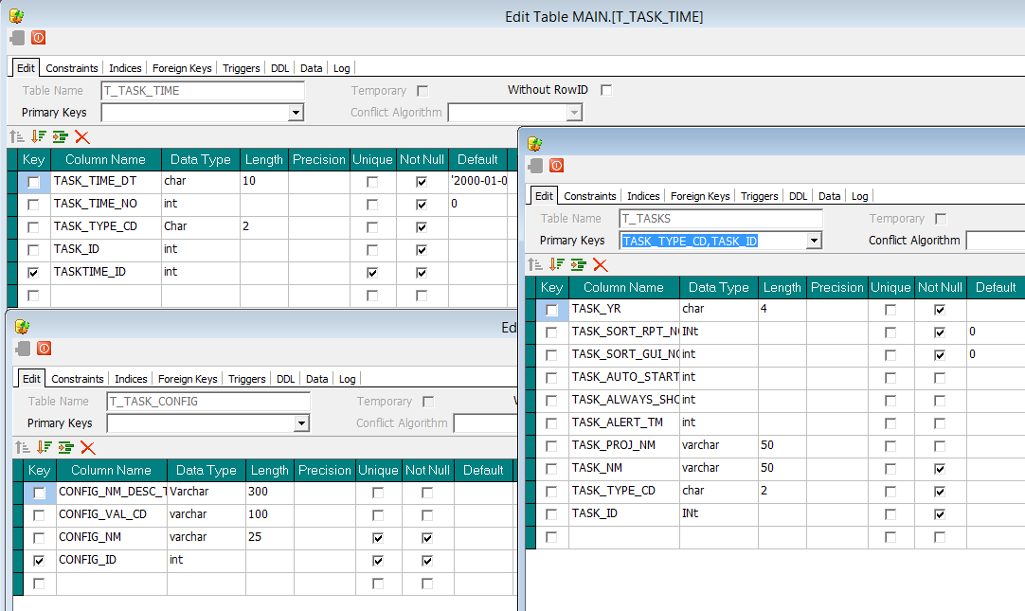

PCT_Notes_DB
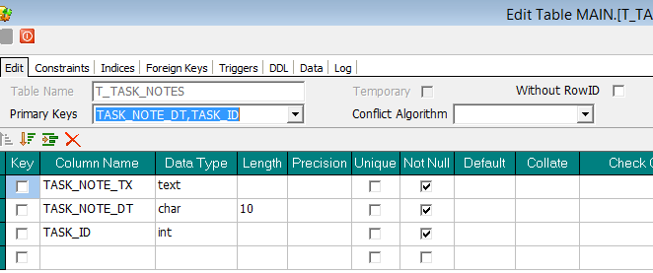

Installation
Unzip the distribution package into a folder and execute from there. The program writes to the folder, so do not use a folder where Windows UAC controls will interfere with operation. Create a shortcut to the PCT Punch Clock Timer program for your Start menu to have the program start whenever your PC starts.

